Homework # 2

Ruchi Panwar(rpanwar@kent.edu)

Software Testing

Fall 2015

Professor: Dr. Gregory S DeLozier

Sept 12, 2015

**1.** Get software installed on your computer as described in the Prerequisites and Assumptions section of the TDD book. Make sure it all works correctly, and that you can write small Python programs and run them.

**Prerequisites and Assumptions**

**1. 1** The Firefox web browser



**1.2** The Git version control system

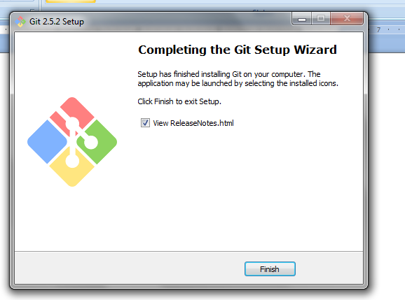

1.2.1 Python 3.4

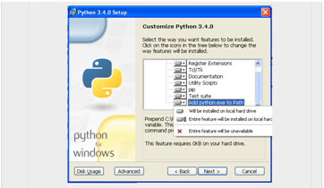

1.2.2 Create symlink in Git Bash Binary folder

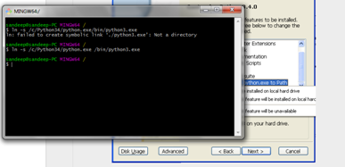

1.2.2 Check for Pip3 availibility

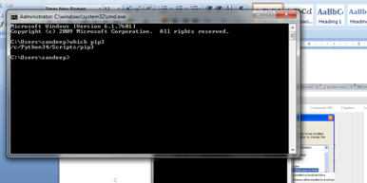

1.3 Django Installation

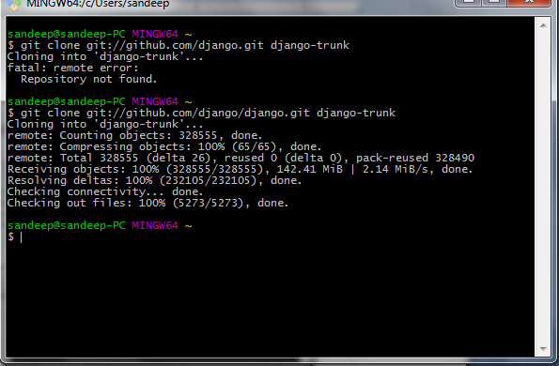

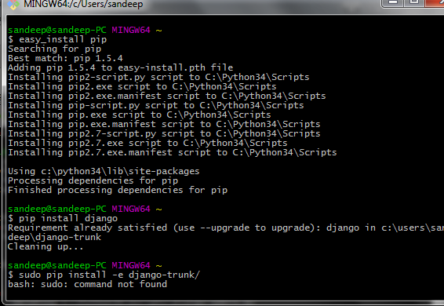

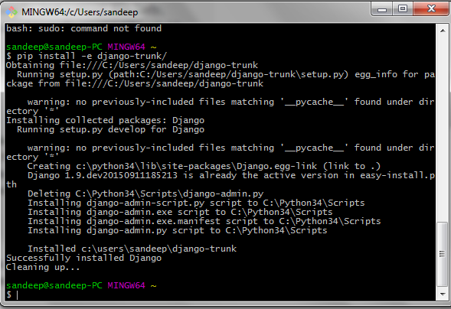

1.4 Selenium Installation

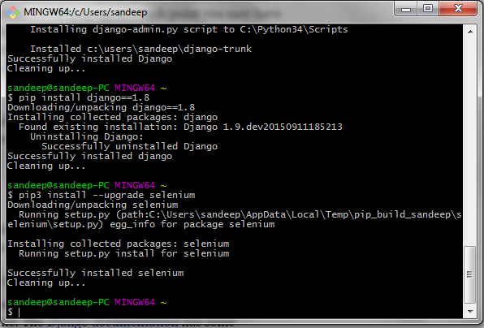

1.4 Small Program to check , if everything works fine

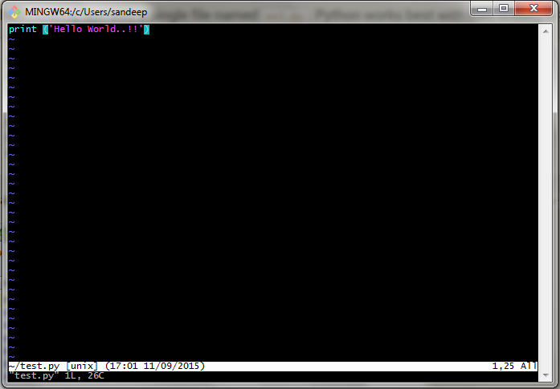

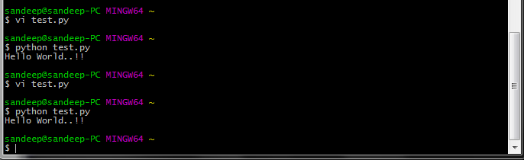

**2**. Read the first chapter of the TDD book.

Following are the screen shots for the example (tried and tested myself) shown in the chapter 1

